

NEXT METERS GLOBAL:
Paapri Cloud Technology
SUPPLY PLANNING PROCESS FLOW

All the steps are done via Administrator role.

What is Supply Planning?
NetSuite Supply Planning helps supply planners determine how to best establish criteria to fulfil demand plan requirements. Supply planning uses sales order details to generate dependent demand for work order components. The objective is to balance supply and demand to achieve your organization’s financial and service objectives.
Supply plans generate a recommended schedule for purchasing or manufacturing items for supply. A supply plan lists the recommended purchase orders and work orders that can increase item supply based on lead times and expected demand. Planners can create multiple supply plans which can vary depending on the planner’s criteria, such as planning horizon, planning scope, and planning rules.
Supply Planning includes processes and steps that enable supply planners to balance supply and demand to achieve an organization’s financial and service objectives. The following diagram represents the NetSuite Supply Planning process:

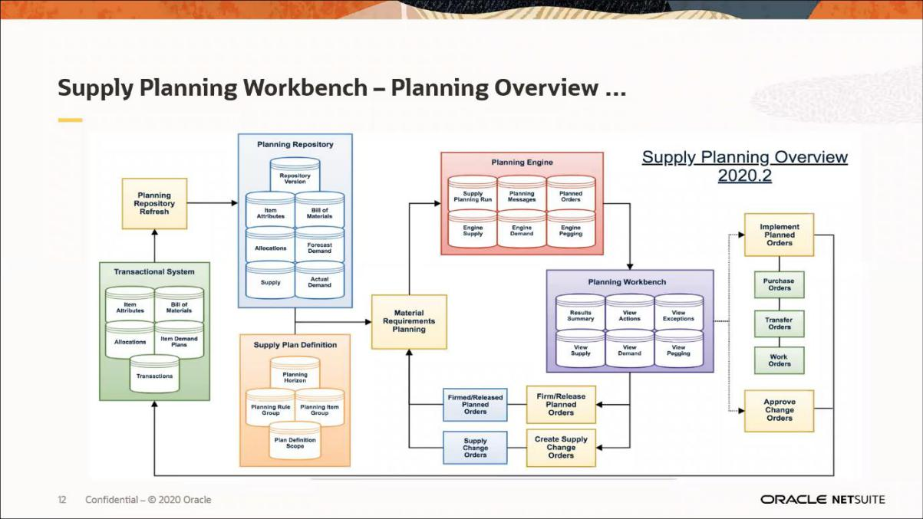

Prerequisites for Supply Planning
Navigate to Setup -> Company -> Setup Tasks -> Enable Features.
- Under the Items and Inventory subtab, the following features must be activated.

  - Multi-Location Inventory – for the assembly item stock levels needed for the supply plan

  - Assembly Items - to enable planning for manufactured items.

  - Advanced Bills of Materials - where component assembly items are stored to ensure that the assembly components are available.

  - Work Orders - the order that builds the assembly item must be included in the supply plan.

  - Advanced Inventory Management – to include reorder point and safety stock levels in the supply planning run.

  - Material Requirements Planning – to activate the supply planning feature.

  - Demand Planning – to are use demand plans (forecasts) with supply planning.

  - Advanced Item Location Configuration – This feature has not been mentioned in the SuiteAnswers. This must be activated too.
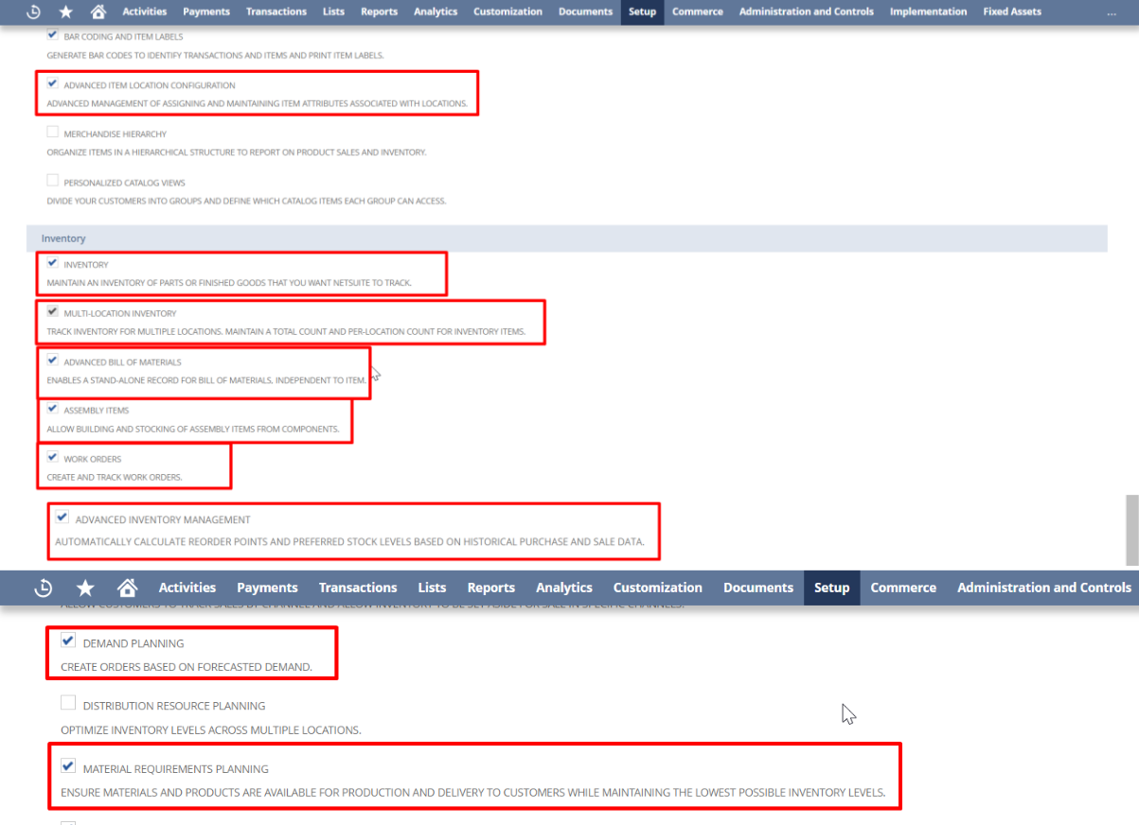

Navigate to Setup -> Accounting -> Preferences -> Accounting Preferences
- Under the Approval Routing subtab, check the Purchase Orders box.
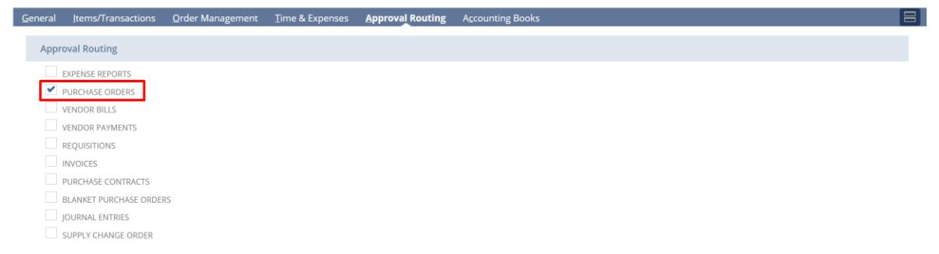

Navigate to Setup -> Accounting -> Preferences -> Inventory Management Preferences.

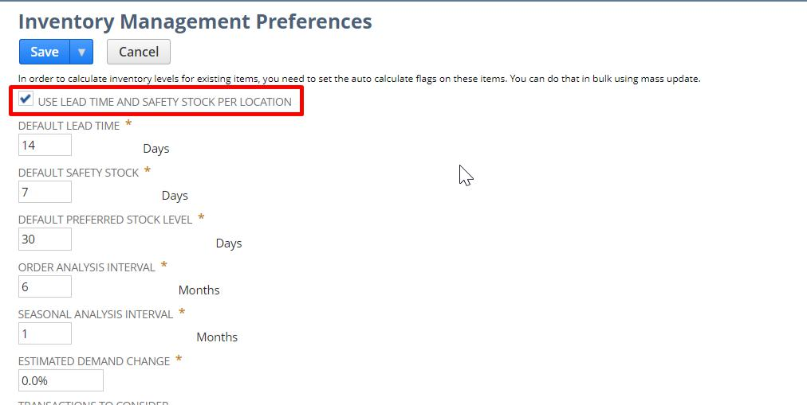
- Check the Use lead Time and Safety Stock per Location box.

Setting Up an Item for Supply Plan
While setting up the item, under the Purchasing/Inventory subtab, select the Replenishment Method as Material Requirements Planning (MRP) for Raw Materials/Stock Items & Master Production Schedule for Finished Goods/Assembly Items.
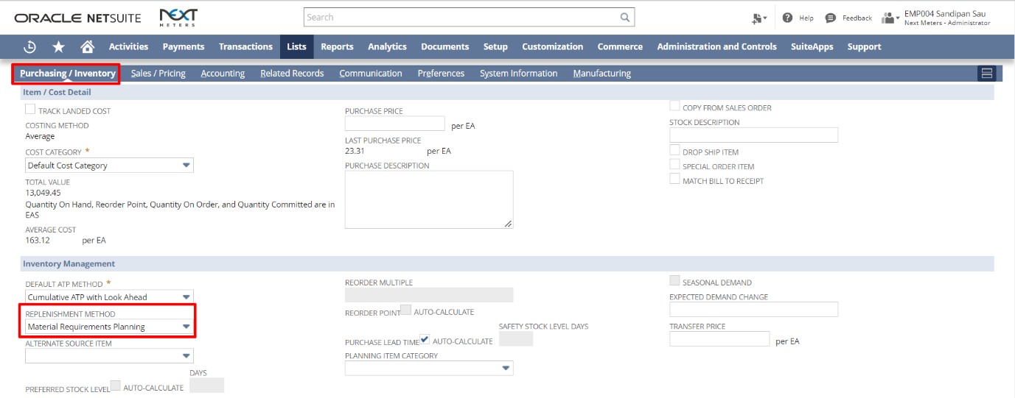

Under the Purchasing/Inventory (subtab) -> Location (Sublist), edit the location for which you want to configure Planning details.
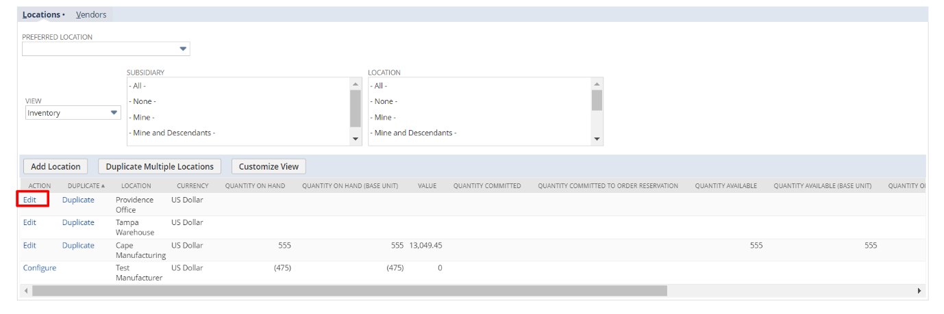

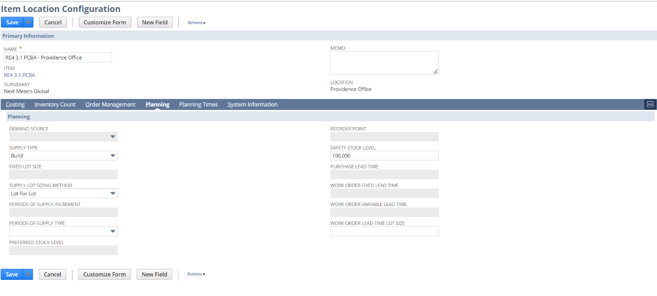
Under the Planning subtab, enter the details like Safety Stock Level and other relevant values.

Inputs to the MR
There are two inputs the MRP:
- Supply Plan Definition - Supply Plan Definition enables planners to establish the criteria to be used for supply planning. The plan definition provides the information that drives the supply planning process, such as planning horizon and planning scope. For example: you can run supply planning at multiple facilities at one time. A supply plan definition provides a permanent holding place for your planning criteria and planning results.

Planning Repository - The Planning Repository stores related planning information that enables you to control how often NetSuite updates planning inputs. The repository refresh process accumulates the most up-to-date data from NetSuite to use for supply planning. The planning process calculates projected available quantity, generates supply orders, and action and exception messages

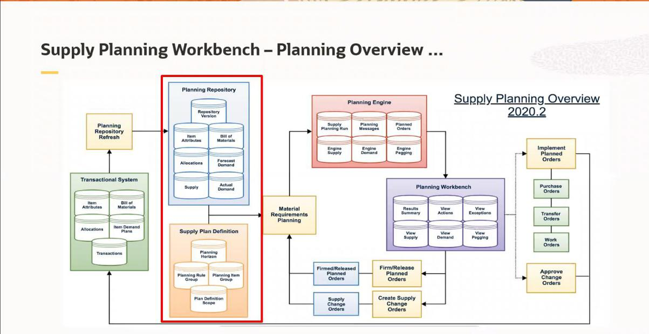

Creating Planning Item Category
Planning item categories organize and display items in a hierarchy. Due to the volume of data involved in supply planning, this hierarchy helps you to aggregate and inspect items more efficiently.
- Navigate to Lists -> Supply Planning -> Planning Item Category -> New.
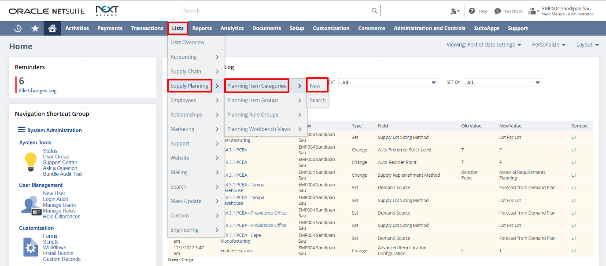
- Give a name to Planning Item Category. User can also give a Description for the planning item category. Click Save.
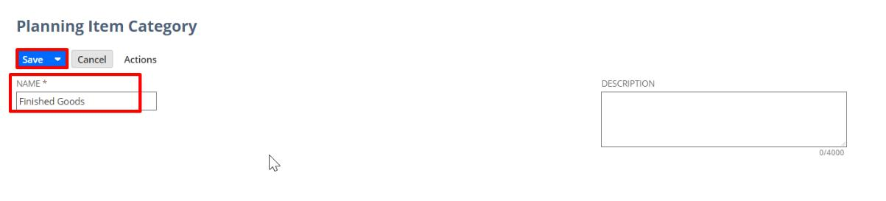

On the Item Record, under Purchasing/Inventory subtab, for Planning Item Category, select the Item Category created in the above step from the dropdown list.
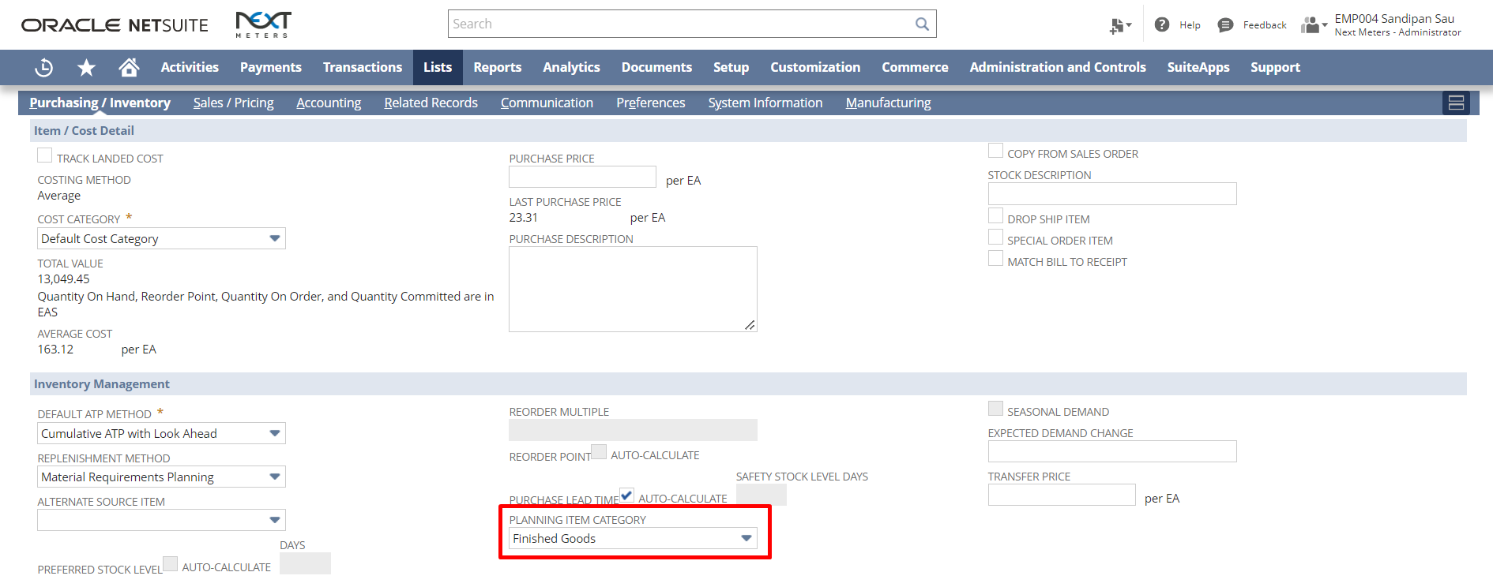

Note: For selecting a Planning Item Category the Replenishment Method must be Material Requirements Planning or Master Production Scheduling.
Creating Planning Item Group
Supply Planners want to specify which items are in a plan at the item category or item level. A planning item group provides a reusable (across different plans) method for specifying a set of items to be planned together.
- Navigate to Lists -> Supply Planning -> Planning Item Groups -> New.
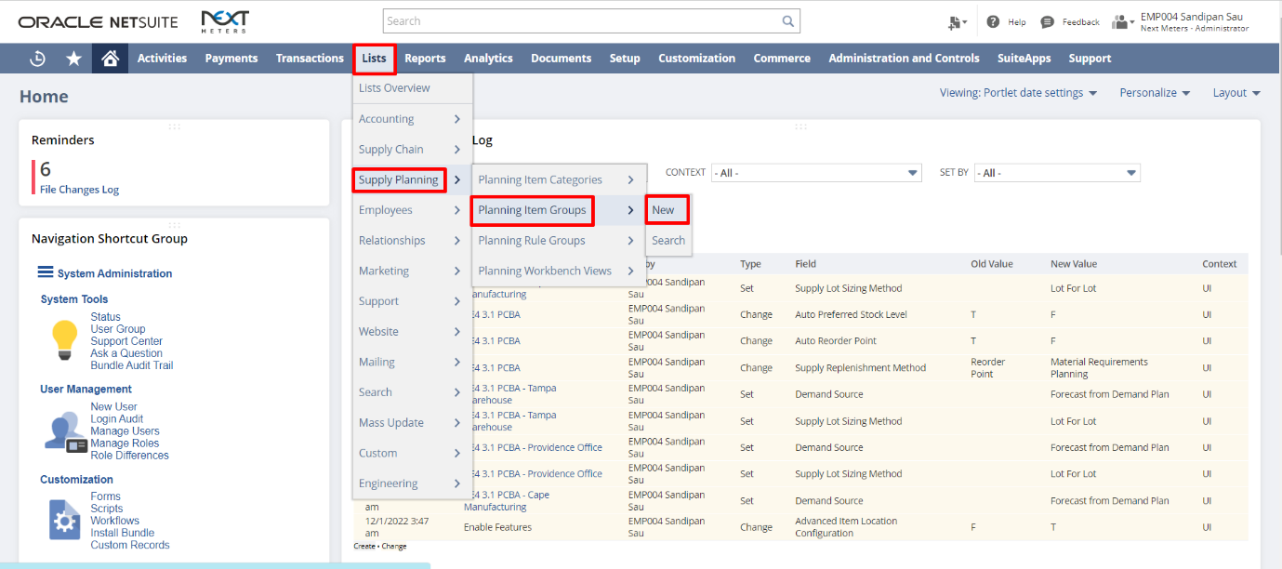
- Give a name to Planning Item Group. User can also give a Description for the planning item Group. Under the Planning Items subtab, for item type either select Planning Item Category or Item. If you have selected Planning Item Category, select, and add the Item Categories you want to plan together. If you select Item, select and add the Items to plan for together.

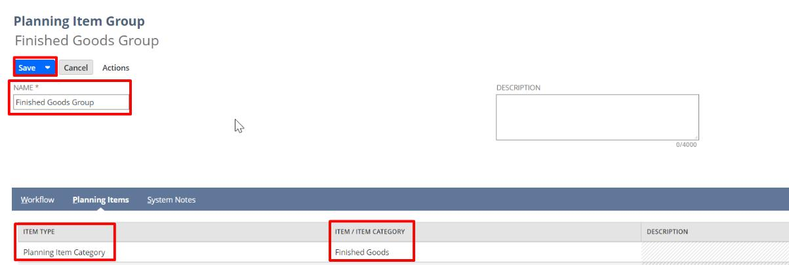

Creating Supply Plan Definition
Supply Plan Definition enables planners to establish the criteria to be used for supply planning. The plan definition provides the information that drives the supply planning process, such as planning horizon and planning scope. For example: you can run supply planning at multiple facilities at one time. A supply plan definition provides a permanent holding place for your planning criteria and planning results.
- Navigate to Transactions -> Supply Planning -> Supply Plan Definitions -> New.
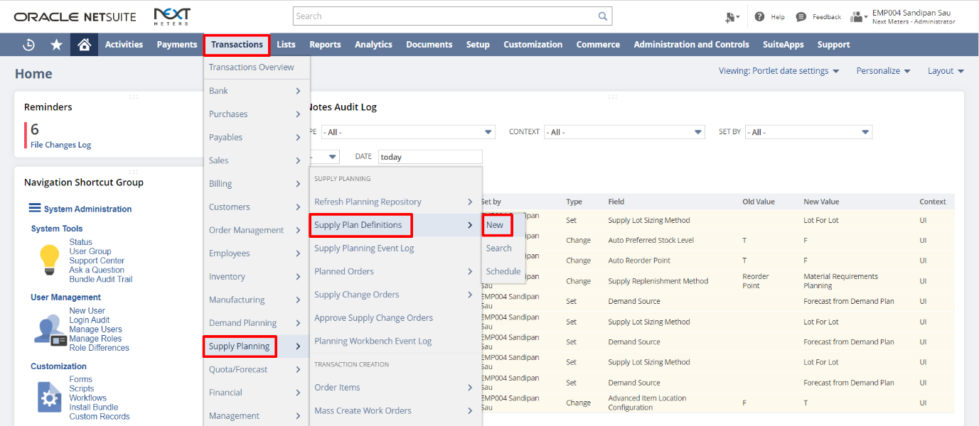
- Enter a Name for the Supply Plan Definition. Select the Planning Item Group. Enter the Planning Horizon (In Days).
Select the Location for which you want to create the Supply Plan Definition. Select their demand source type as either Sales Order or Demand Plans or Sales Order and Demand Plans. Check the Consume Forecast checkbox. Click Save.
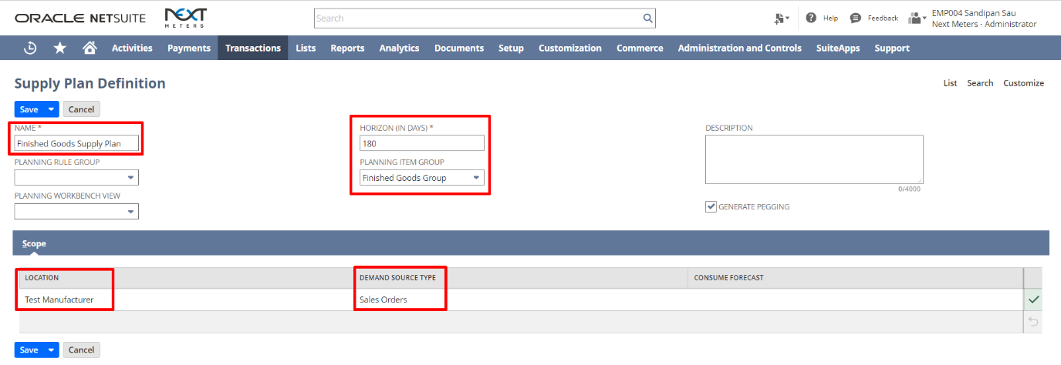
Refreshing Planning Repository
You can refresh the Planning Repository each time manually before review Supply Planning Workbench. You also have the option to schedule the refreshment of Planning Repository on a allocated time.
- Navigate to Transactions -> Supply Planning -> Refresh Planning Repository.
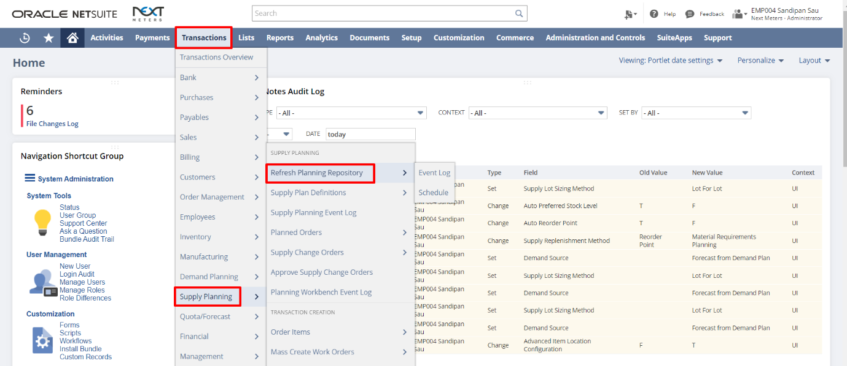
- Select Complete Refresh to purge data from the repository and reload all item setup data and transactions for the supply plan. Select Net Change to reload data that has changed since the last repository refresh to present the latest supply planning data. Select a Refresh Option: Item Setup or Item Setup and Transactions.
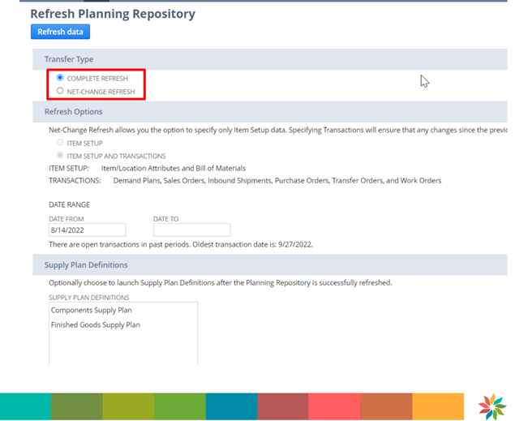

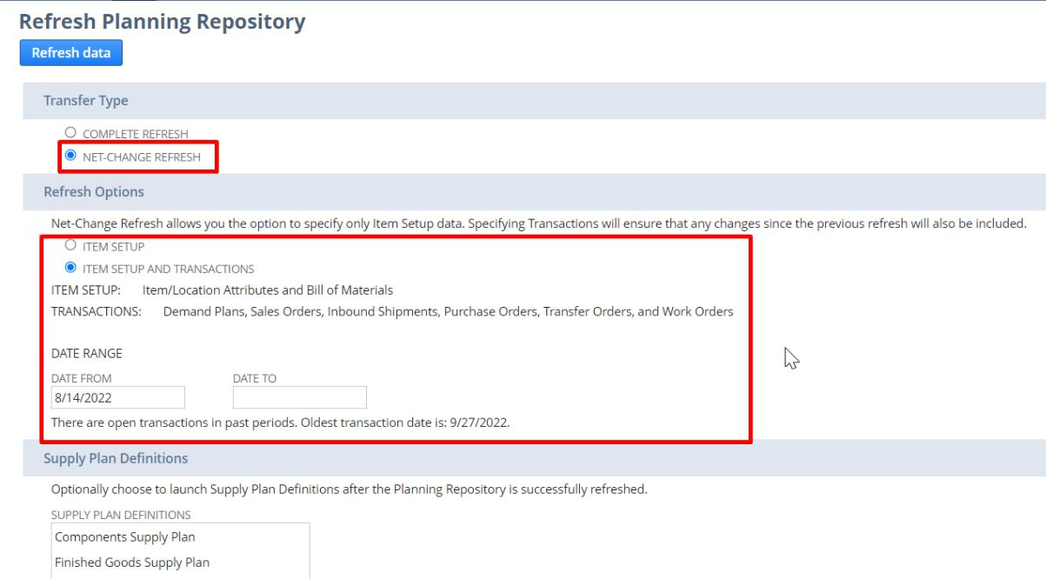
- If the user selects Net Change Refresh, the Refresh Options get enabled. Select Item Setup or Item Setup and Transactions and select the Date Range.

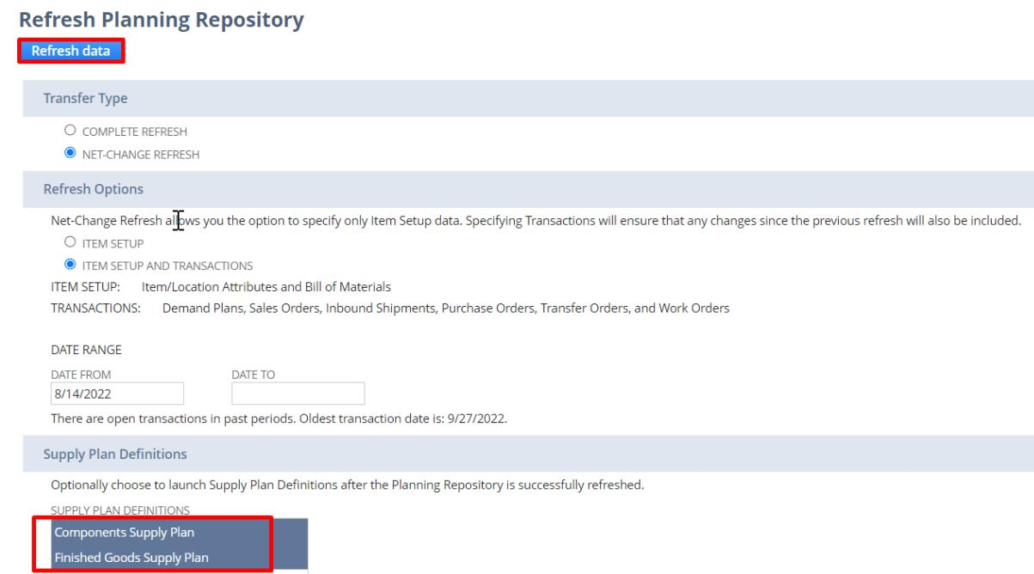
- Click on Refresh Data button. The user can optionally select a Supply Plan Definition to launch it directly after the Repository has been successfully refreshed.

- The Planning Repository Event Log page opens. Here the user can see the status of the refresh and if there were any errors or not.
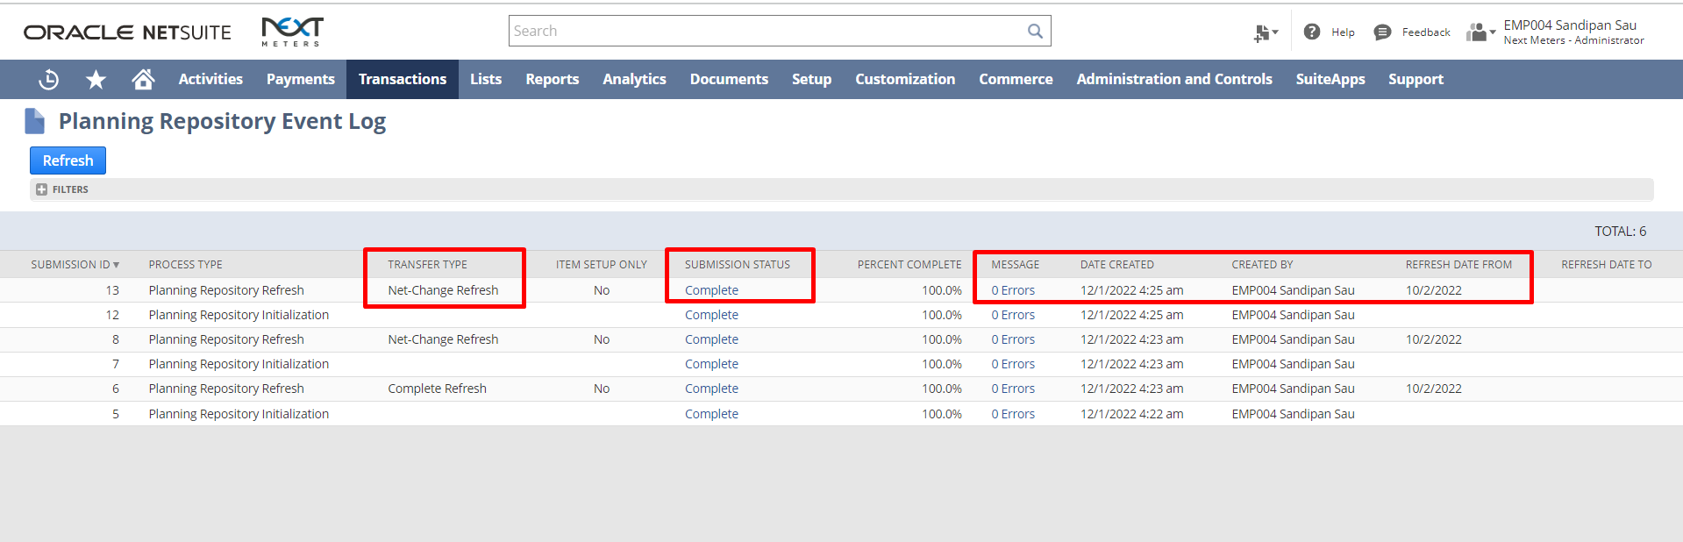
- To create a schedule for Planning Repository Refresh, navigate to Transactions->Supply Planning-> Refresh Planning Repository->Schedule.
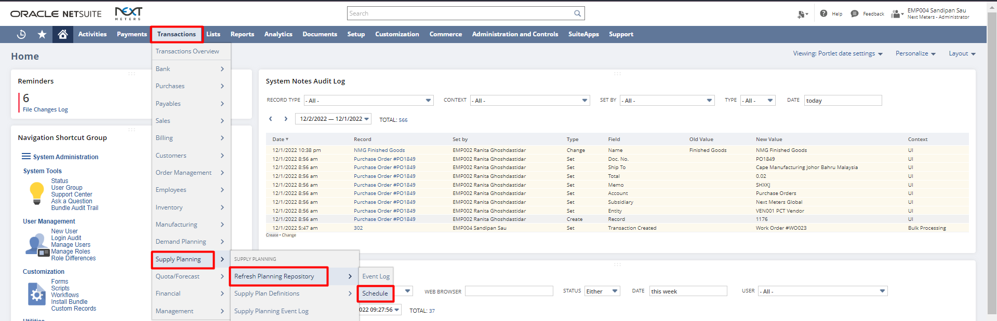
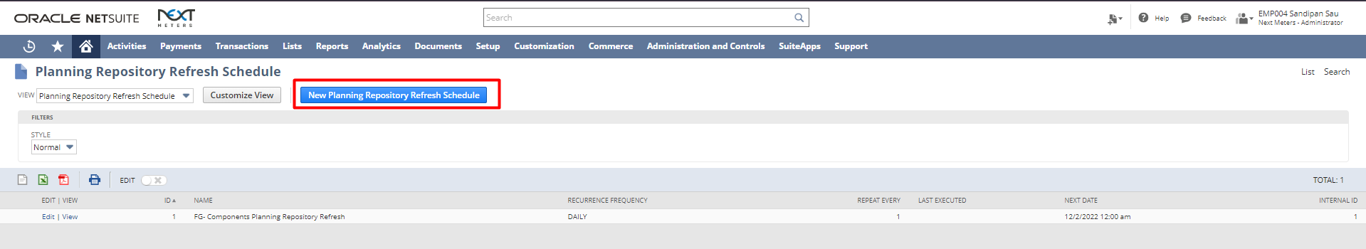
Click “New Planning Repository Refresh Schedule” button.
Select a Transfer Type. Complete Refresh Options. Choose Supply Plan Definitions to launch after Refresh. Enter Details for Scheduling the Planning Repository Refresh.
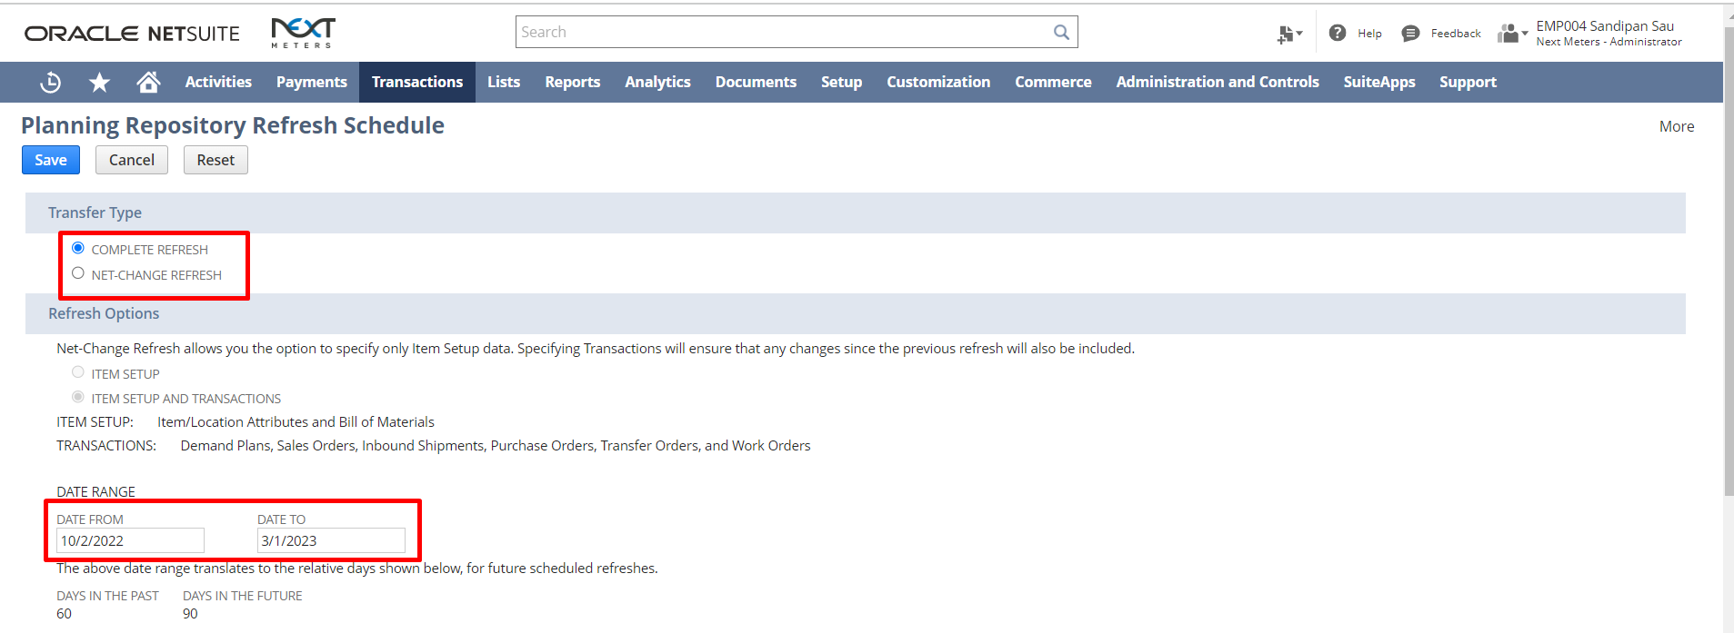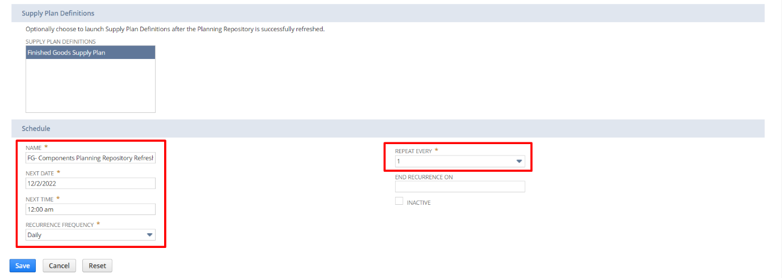
Launching Supply Planning Workbench from Supply Plan Definition
- Navigate to Transactions -> Supply Planning -> Supply Plan Definitions
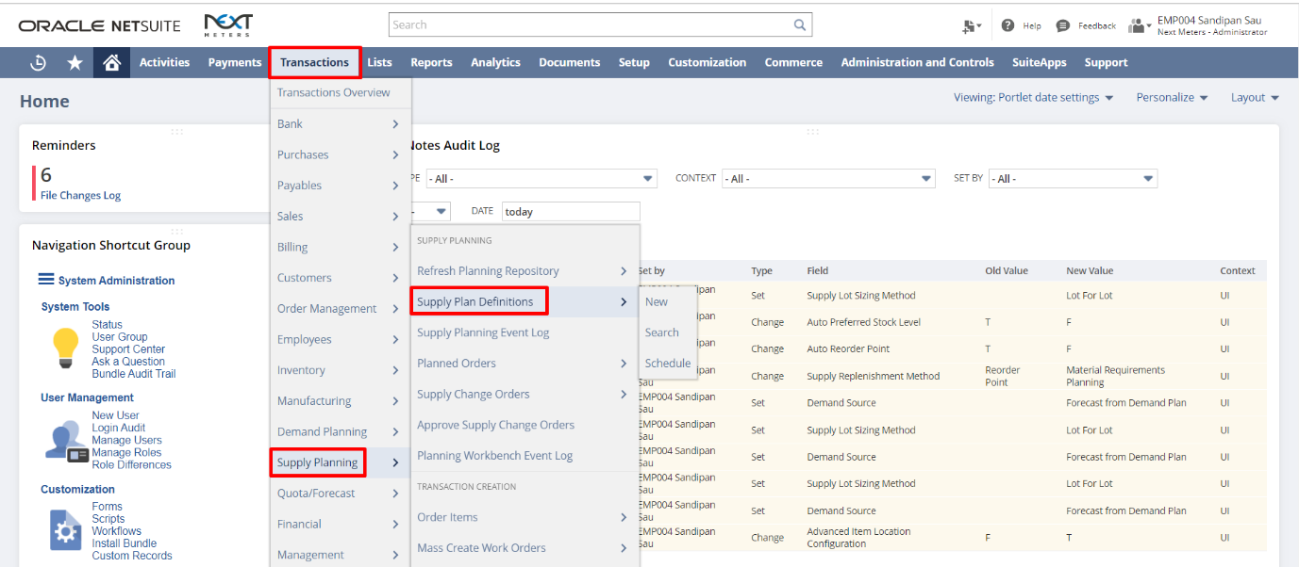
- Click on the Launch button.
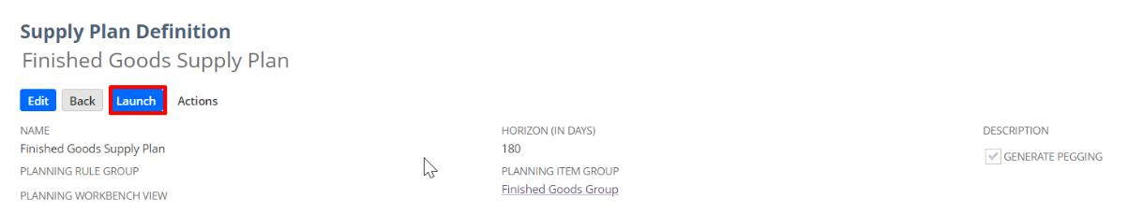
- After this submission status becomes Complete for the process type Material Requirements Planning, click on View Results under Planning Workbench column.
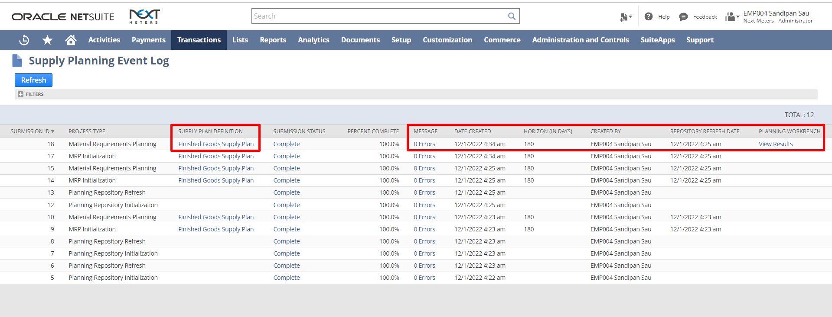

Supply Planning Workbench

- After clicking on the View Results hyperlink, the Supply Planning Workbench opens.

The Supply Planning Workbench enables planners to view information supply and demand orders within the supply plan. After reviewing the results, you can then take action to adjust your supply plan to ensure that customers receive their orders complete and on time. The workbench essentially, helps to guides planners on how they will execute their supply plans.
- The name of the Supply Plan Definition and other details is displayed on the top section. Item Filters on the left section.
There are four different types of messages/outputs of the Supply Planning Workbench. o Action – System’s recommendation for the supply plan.
o Exception – Challenges on the supply plan. Reasons behind the Late Demand quantity. o Supply – Information regarding the Supply Orders included in the Supply Plan.

o Demand – List of Demand Orders and Sources that needed to be fulfilled by the Supply Orders on the Supply Plan.
Below the Top section there are filters available to filter the messages.
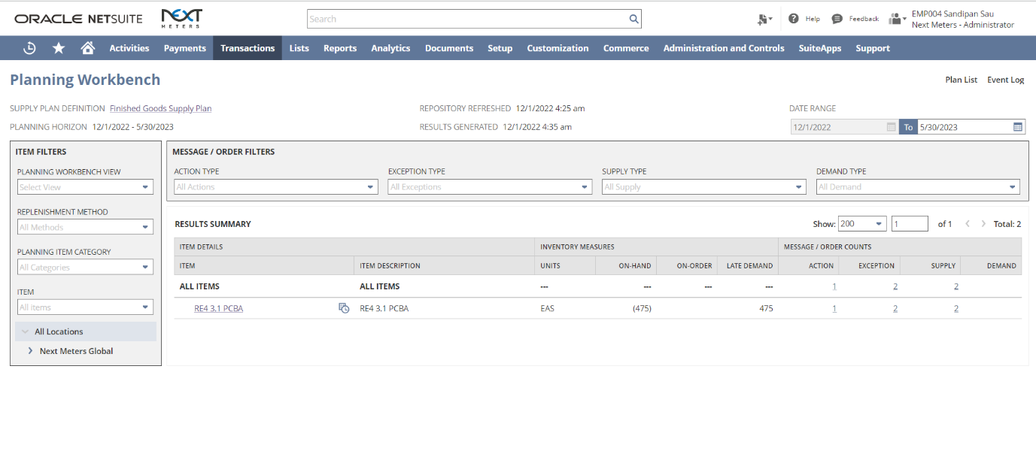
- User can view the Demand Orders under the Demand subtab.
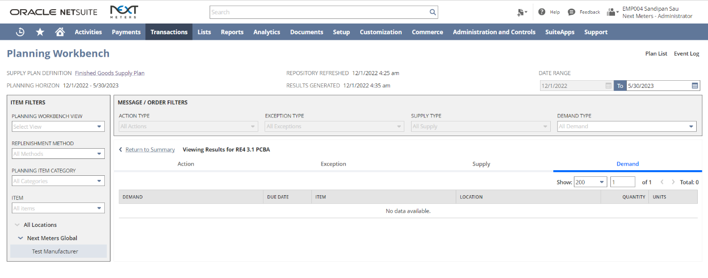
- User can view the Supply Tab to view the Supply for an Item.
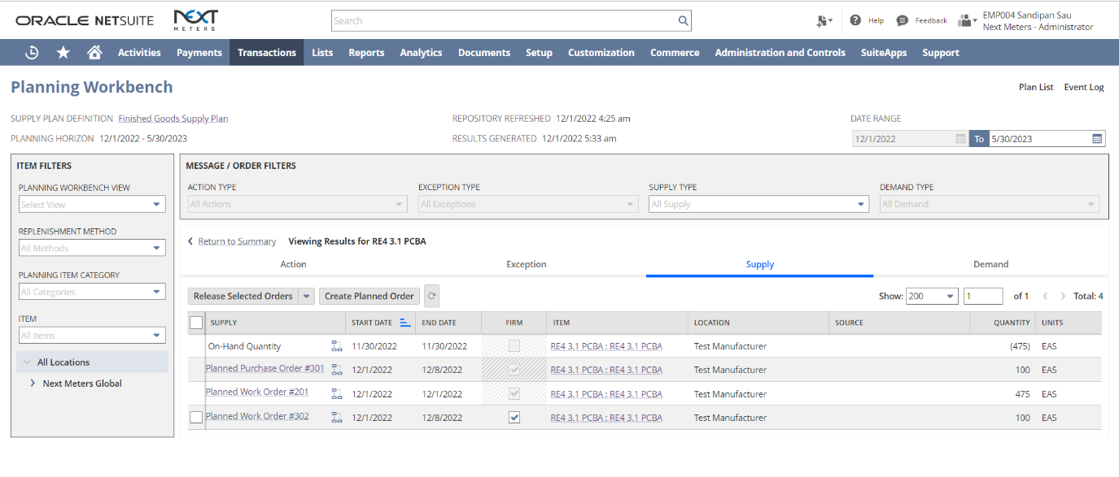
- User can view the Exceptions tab to check for issues if any in the Supply Plan.
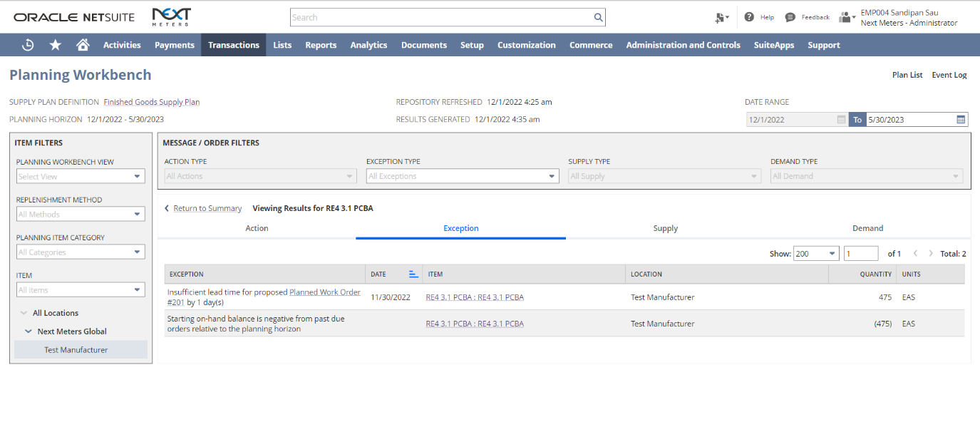
- User can view recommended actions to solve issues with the Supply Plan under the Actions Tab. Users can create complete one or more actions at a time. Check the checkbox for the actions and click on Perform Selected Actions.
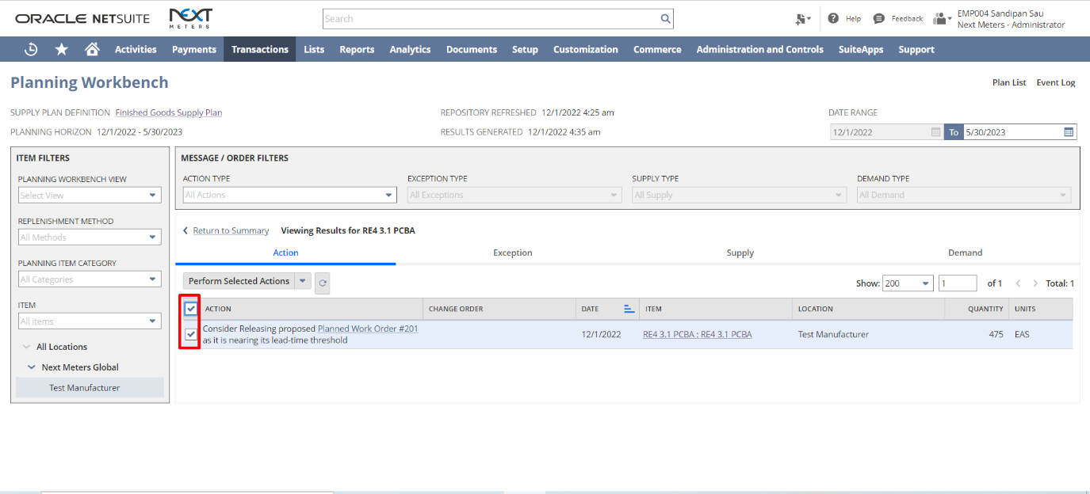
- Click Ok on the Prompt if you want to complete the actions selected.
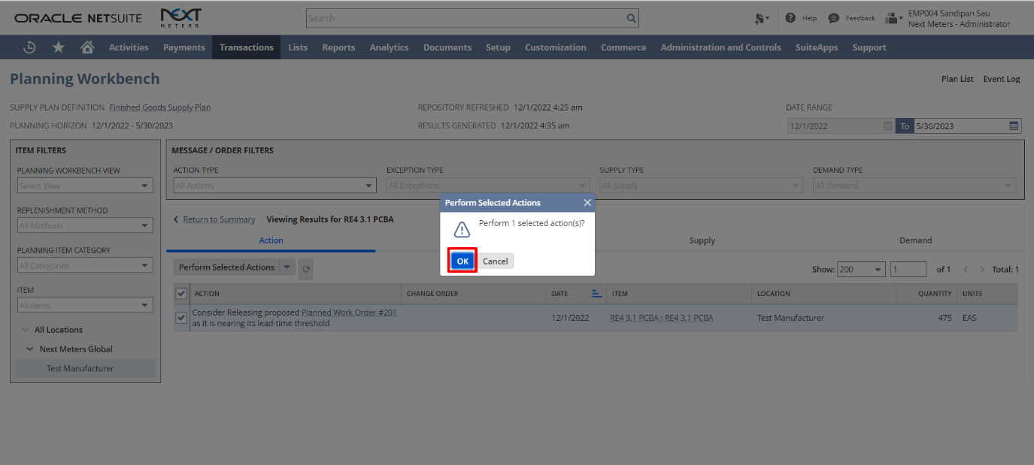
- Click on the Refresh Data icon. Once the data refreshes, the Action checkbox is greyed out for the completed actions.
Converting Planned Purchase Orders to Purchase Orders
- Navigate to Transactions->Purchasing->Order Items.
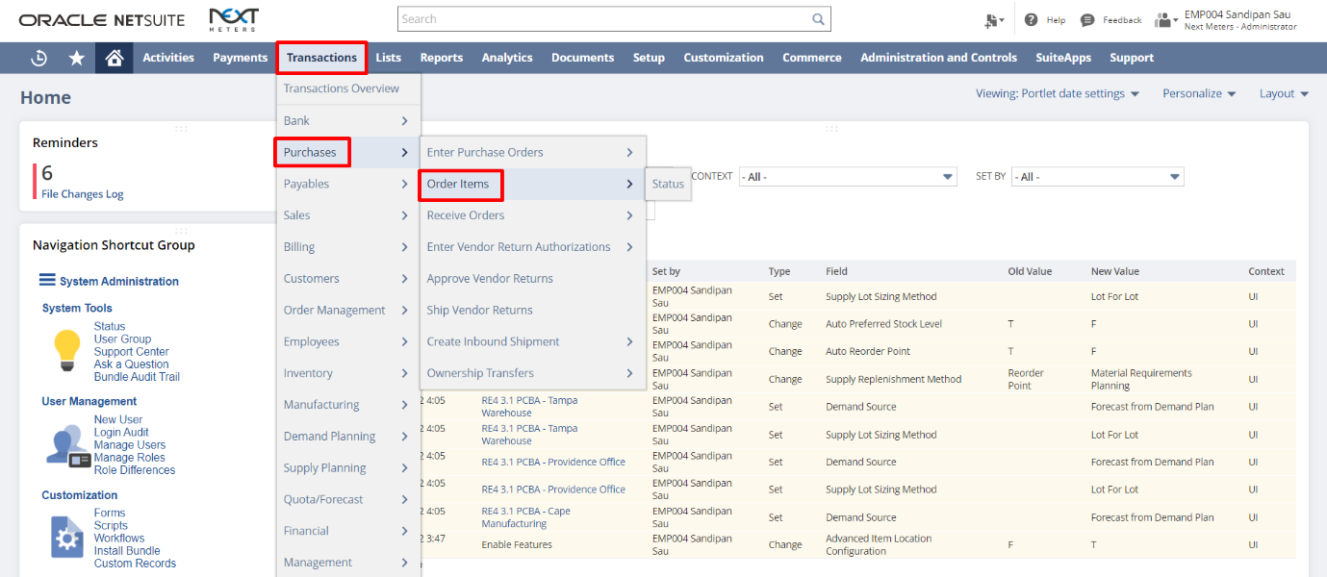

- Under the Planned Orders subtab, the Released Planned Purchase Order will be listed. Select the ones to be converted to Purchase Orders. Scroll to the right and review other details. Click Submit.
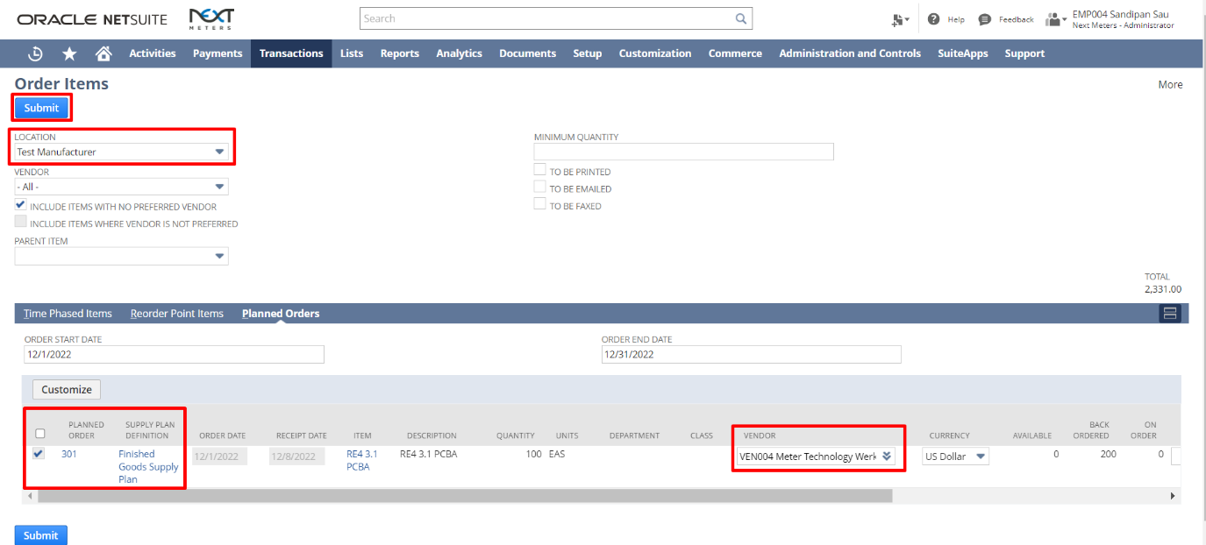

- Purchase Order for the selected lines will be created in the background.

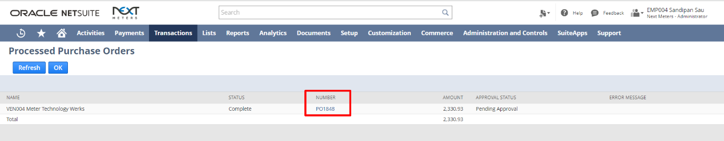

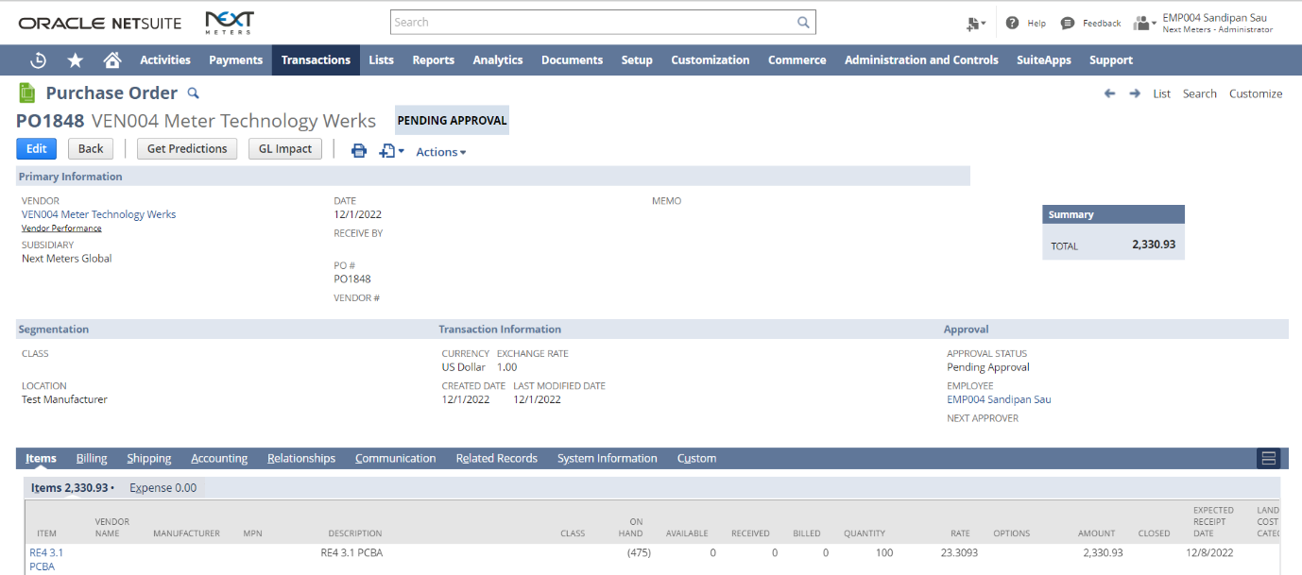

Converting Planned Work Orders to Work Orders
First, we must release the Planned Work Order. To do so, under the Supply Tab, check the checkbox for the Planned Work Order you want to Release and click “Release Selected Orders” checkbox.
(Ignore this step if Planned Work Order is already released by performing Actions suggested by Supply Planning Workbench).
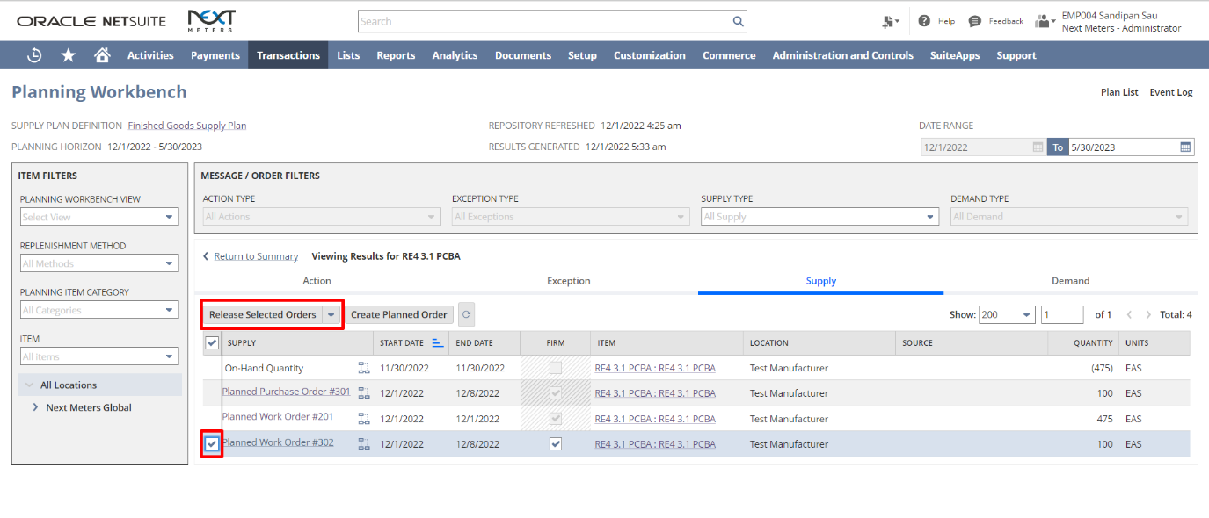
Click Ok on the Pop Up to confirm Release of the Work Order.
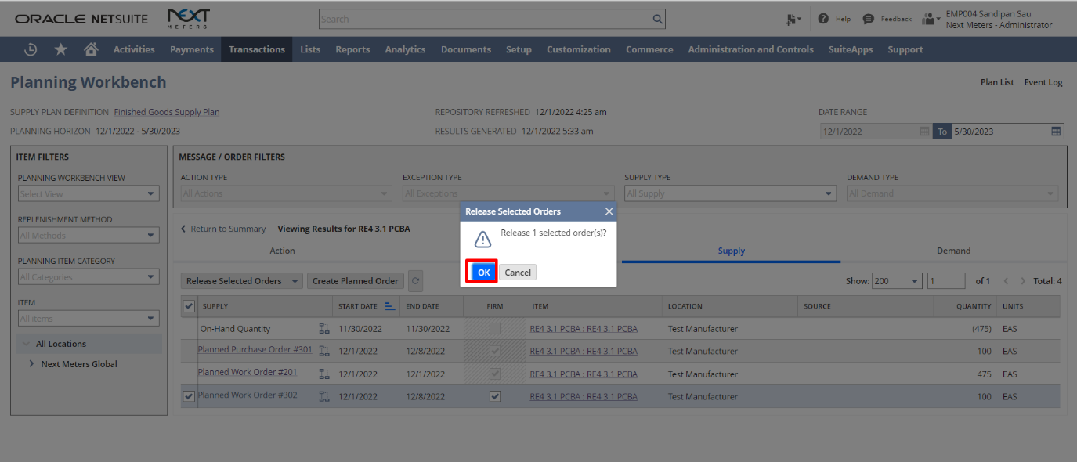

To convert the Planned Work Order to an Actual Work Order, follow the below steps:
- Navigate to Transactions->Manufacturing->Mass Create Work Orders.
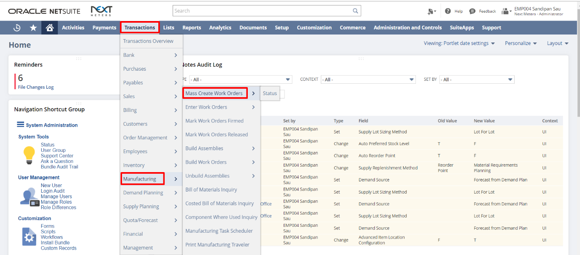

- Under Planned Orders subtab, select the Planned Work Orders to be converted. Review/update other details and click Submit.
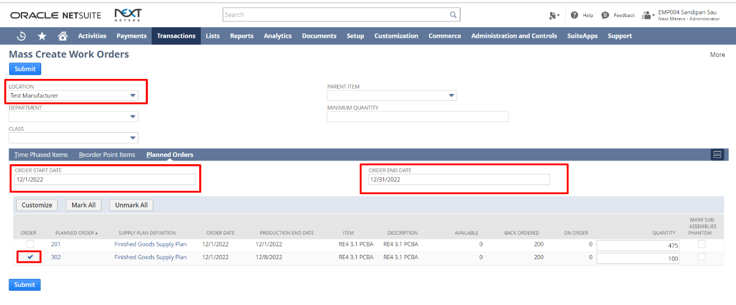
- On the Process Status page, click on the Submission Status hyperlink to view the created work orders.
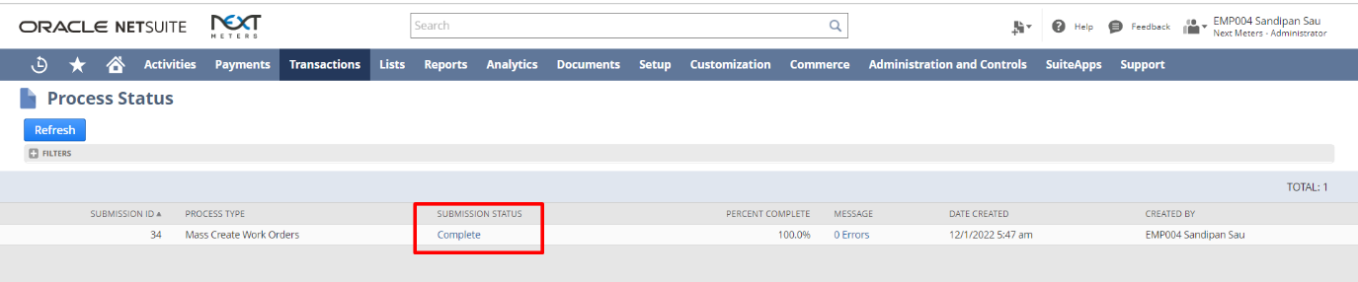
- The details of the Work Orders gets listed. The created Work Orders will be created in Planned Stage by default.
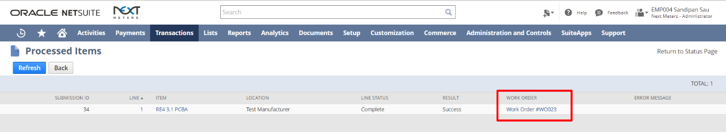
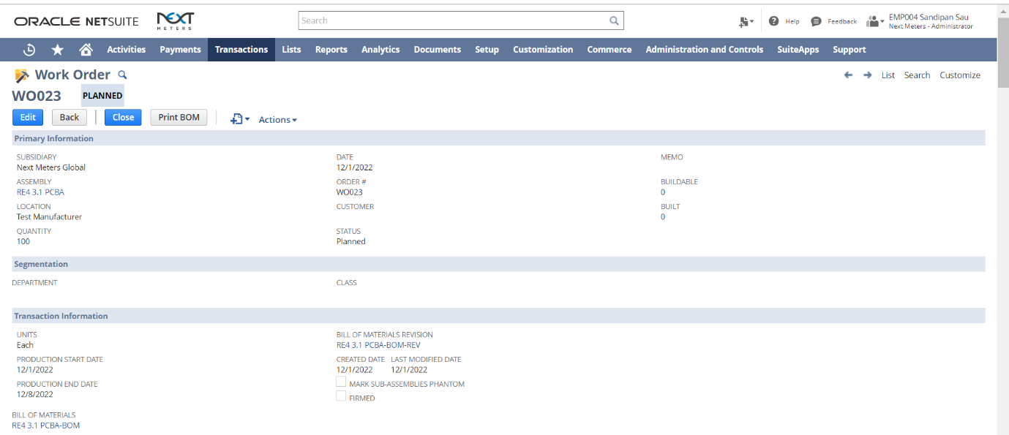

Signature: _____________________________ Date: ______________________

Disclaimer:
Upon signing off on the process flow document, you are confirming that the process has been set up per the SOW within NetSuite per your business's needs. Any changes or modifications requested after sign-off will need to be a "change request" at an additional fee.

*** PLEASE ensure that you have logged into NetSuite and tested the process prior to signing off on the setup. Paapri requires sign-off on this document prior to moving forward with any additional design meetings.

